HYPERLANE
Game Design Document · Version 2.2

This document is the single source of truth for Hyperlane's design. Decisions recorded here are settled unless changed through the Open Decisions log in Section 16.
Changes in v2.2: player progression added as Section 12 - Account Level, Class Mastery and Season Rank, with earned characters as non-tradable entitlements. Carried forward from v2.1: chain scoring, dual leaderboards, the Sweeper, Last Breath disabled in Versus, Surge Jump repurposed to buy line rather than life, and Mach raised to Chassis 2.
Naming risk: "Hyperlane" is also the name of an established blockchain interoperability protocol. Given that this project settles on Stellar, the collision is in the same industry. Resolve before registering any organisation, domain or trademark.

1. Overview

Field | Value
Genre | Top-down 2D endless runner with survival and versus modes
Platform | Web browser (desktop first, mobile web to follow)
Engine | Phaser 3 + TypeScript
Modes | Endless · Time Attack · Versus (2P)
Classes | Dasher, Bulwark, Healer. Free to all players, always.
Characters | Mach (Dasher), Brute (Bulwark), Lynn (Healer)
Score | Chain multiplier. Distance scores nothing.
Blockchain | Stellar / Soroban — settlement and ownership only
Status | Pre-production

1.1 Elevator pitch
Hyperlane is a browser-based endless runner where riders weave through a hostile lane at speed. Three classes play by three different rules: one evades, one absorbs, one endures. You are not scored on how far you got. You are scored on what you never touched.

1.2 Design pillars
- Readable at speed. The player must always understand why they died. Nothing kills without warning.
- Three ways to survive. Dasher evades, Bulwark absorbs, Healer endures. Class choice is a playstyle commitment, not a stat upgrade.
- Survival is the price of scoring, never the score. Staying alive earns nothing. Staying clean earns everything.
- Every class is free. USDC buys identity and appearance. It never buys ability, survival, or score.
- Every resource is visible. If a mechanic changes the outcome of a run, the player can see it on the HUD before it matters.

2. Scoring

This is the most important section in the document. Every balance decision downstream depends on it.

2.1 Why distance cannot be the score
Distance is speed multiplied by survival time — precisely the two quantities the classes trade against each other. Score distance directly and speed becomes score, which means speed can no longer be a balance cost. But speed being a cost is the only reason Lynn is permitted four Rider and a second life.
Rank on survival time and Lynn owns the board. Rank on distance and Mach owns it. Correct it with per-class multipliers and players argue about the multiplier instead of playing the game. There is no fair pooled leaderboard while distance is the score.

2.2 The chain
Score the one thing equally available to every class and equally denied to every class: clean passage.
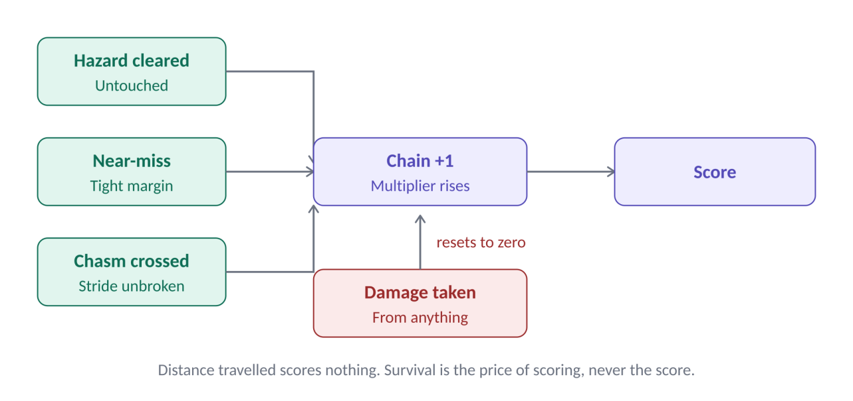
The chain. Every hazard passed untouched raises the multiplier. Any damage, from any source, resets it to zero.
Event | Effect
Hazard cleared untouched | +1 chain, points awarded at the current multiplier
Near-miss | Bonus points. For Mach, also Momentum.
Chasm crossed without breaking stride | Large bonus
Smash (Bulwark only) | Counts as a clean clear. Chain continues.
Any damage taken | Chain resets to zero
Distance travelled | Nothing

2.3 What the chain does to each class
- Brute's plates stop being a score advantage. He tanks a chip hazard: he lives, and his chain dies. Chassis saves his life, not his run. Smash is his exception — he is the only class in the game who scores by hitting something.
- Lynn's revive becomes expensive. She returns at 1 Rider with her chain at zero. Second Wind buys life at the cost of score, which is the correct trade for a sustain class.
- Mach's two economies fuse. Near-misses feed Momentum and points together. Playing him optimally for score is identical to playing him optimally for survival: skim everything, touch nothing.
Speed remains a cost. It is simply no longer a score. That is the whole trick.

2.4 Leaderboards
Board | Ranked on | Scope | Purpose
Class boards (×3) | Distance | Per class, global and local | Legible and casual. Fairness is free — you are only compared to your own class.
Open board | Chain score | Pooled across all classes | The prestige board. Class-agnostic by construction, not by tuning.
Versus rating | Wins and losses | Pooled | Match outcomes only
Both boards come from the same run. One leaderboard screen, one toggle. Distance for the player who wants to know how far they got; chain for the player who wants to be the best.
Chain scoring is harder to explain than distance. Mitigate it by showing the chain enormously in the HUD and making the reset feel awful — screen shake, sound drop, the number falling.

3. Game Modes

3.1 Endless (single-player)
- Goal: Build the longest chain. Distance is tracked, but scores nothing on the Open board.
- Difficulty: Hazard density and lane speed scale continuously with distance travelled.
- Rewards: Coins collected during the run mint to the player on verification.

3.2 Time Attack (single-player)
- Goal: Clear a fixed-length lane in the shortest time.
- Difference from Endless: The lane is authored, not procedural. Every player faces the identical hazard sequence.
- Lethal hazards are more common here, not less. A lethal hazard in Endless destroys a run you built. In Time Attack it costs a retry. That makes them the mode's most interesting timing puzzles.
- Rewards: Reduced coin yield. Time Attack is a skill ladder, not a farming mode.

3.3 Versus (two-player)
- Format: Two players, side by side, last rider standing wins.
- Interaction: None. This is PvE. Players cannot collide with, damage, or affect each other. Both run an independent hazard sim from a shared seed, so both face the same lane.
- The Sweeper: A lethal line advances up the lane behind both players at a fixed pace, visible from the first frame. It is contact-death, no exceptions. Fall behind and it takes you.
- Last Breath does not fire in Versus. Lynn may still spend her charge actively as Full Heal. She simply has no free life.
- Scoring: Wins and losses only. Chain is displayed but never banked.

3.4 Why Versus needs the Sweeper
Endless and Time Attack are paced by distance, so Lynn's low speed is a constant, real cost. Versus is last-standing: distance is irrelevant, her cost evaporates, and her benefit is maximal. Without intervention she is strictly dominant, Brute is close behind, and Mach's entire compensation package is worthless.
The Sweeper restores speed as a cost. Lynn must now survive and keep pace. Mach's speed is an asset again. Matches cannot drag. It is the cheapest mechanic in this document and it repairs the mode's entire balance.

3.5 Why Versus is not chain-scored
Both players share a seed. A server cannot distinguish a genuine match from two friends taking turns dying early so that one may farm a clean lane. Match results are collusion-resistant; solo scores inside a two-player lobby are not.

4. The Damage Model

Hyperlane has two health bars, and they are not interchangeable.
Bar | Represents | Damaged by | At zero
Chassis | The bike's integrity. Formerly "DEF". | Chip hazards only | Chip hazards begin damaging Rider
Rider | The player's life. Formerly "HP". | Chip hazards once Chassis is empty, and all heavy hazards directly | The run ends
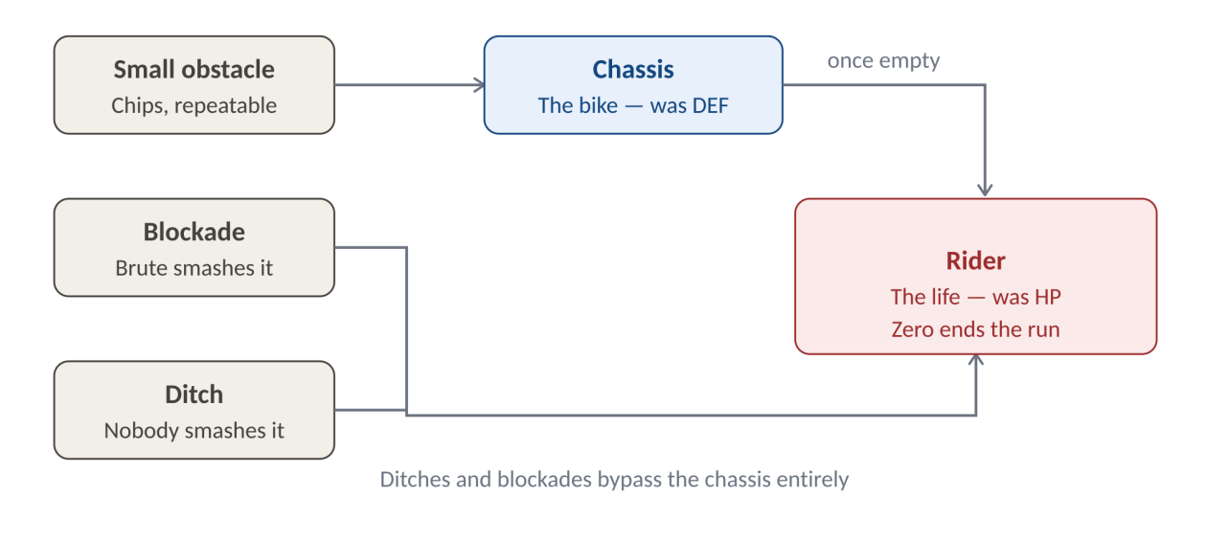
Damage routing. Chip hazards grind the chassis, then the rider. Heavy hazards bypass the chassis entirely.
The rule in one line: the bike protects you from the road, but not from the drop.

4.1 Why the chassis cannot be bought
Bikes are upgradeable with coins, and coins are purchasable with USDC. If a bike upgrade could raise Chassis, USDC would buy survival.
You can tune the bike. You cannot armour it. Upgrades buy handling, acceleration, turn radius and top speed. They never buy a plate.
Chassis is a property of how a class rides, not what it rides. Brute braces and takes the hit; Mach never lets the frame touch anything. All three ride the same silhouette, recoloured to the class palette.

5. Hazards

Every hazard belongs to exactly one tier. The tier determines what it damages and what warning the player is owed.
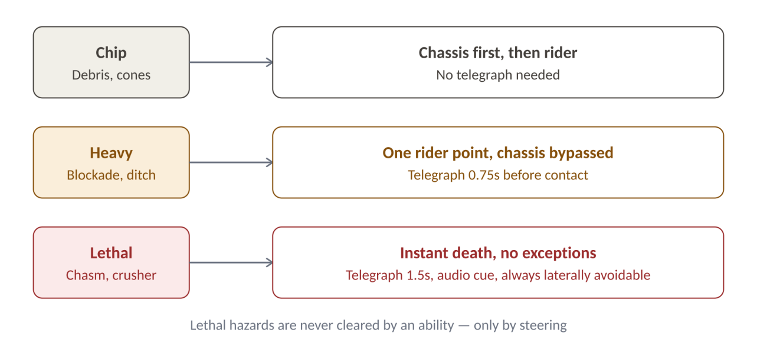
Hazard tiers and the telegraph obligation attached to each.

5.1 Tier definitions
Tier | Damages | Telegraph | Avoidance
Chip | 1 Chassis, then 1 Rider once Chassis is empty | None required | Jump, steer, or absorb
Heavy | 1 Rider. Chassis is bypassed. | 0.75s lane marker | Jump, steer, or absorb
Lethal | Instant death regardless of Chassis or Rider | 1.5s marker, audio cue, edge flash | Lateral steering only

5.2 The hazard set
Hazard | Tier | Behaviour | Notes
Debris | Chip | Static, single-lane | The baseline hazard
Cones | Chip | Static, clustered | Punishes poor lane discipline
Oil slick | Chip | No damage; degrades handling for 2s | Breaks no chain — it damages nothing
Barrier | Chip | Static, low; jumpable | Chassis chip if struck
Blockade | Heavy | Static, tall. Destructible by Bulwark only. | Brute's food source
Ditch | Heavy | Gap in the lane; jumped or steered around | Brute has no answer to this
Chasm | Lethal | Spans several lanes, never all | Steer wide — or, for Mach, Surge Jump
Crusher | Lethal | Descends on a fixed cycle into specific lanes | Timing and lane choice
Lane collapse | Lethal | A lane falls away after a telegraphed delay | Forces a lane change under pressure
The Sweeper | Lethal | Versus only. Advances behind both players. | Cannot be outfought, only outrun

5.3 The telegraph rule
No lethal hazard may ever kill a player who was not warned. A lethal hazard without a telegraph is a bug of the highest severity.
- Lethal hazards are always laterally avoidable. They never span the full lane width. A player with functioning reflexes and no resources remaining can always steer clear.
- Steering wide is always the slow line. It costs speed, coins down the middle, and chain opportunities. Survival is available to everyone. It is never free.
- No ability prevents a lethal hazard. Surge Jump does not save Mach from a chasm — steering does. Surge Jump lets him refuse to steer. See 6.

6. Classes and Characters

6.1 The distinction
 | Class | Character
Is | An ability set | A named identity within a class
Defines | Passive, active, resource, stats, speed | Art, animation, name, personality
Affects gameplay | Yes — entirely | No — never
How obtained | Free. All classes, all players, always. | Bought with USDC, or granted
On chain | No | Yes — Soroban NFT
At launch | Dasher, Bulwark, Healer | Mach, Brute, Lynn — one free default per class
A Mach NFT does not grant the Dasher kit. Every player already has it. It grants that specific rider. This is what makes it impossible for USDC to buy power.
A new character inside an existing class is art and a name: no new code, no balance pass, no new bugs. A new class is a once-a-year event.

6.2 The roster
Class | Character | Colour | Rider | Chassis | Speed
Dasher | Mach | Red | 2 | 2 | High
Bulwark | Brute | Blue | 2 | 4 | Medium
Healer | Lynn | Green | 4 | 2 | Low
Mach was raised from Chassis 1 to Chassis 2. One plate is not a resource, it is a formality — and it made Repair pickups dead loot for him. He remains clearly the most fragile class.

7. Dasher — Mach

Fast, fragile, and always one mistake from the end. Mach does not survive hits — Mach does not take them. His resource, Momentum, is earned by flirting with the hazards he is trying to avoid.
Element | Detail
Colour | Red
Stats | Rider 2 · Chassis 2 · Speed: highest in the roster
Resource | MOMENTUM — a continuously filling bar. Fills while grounded, and fills faster on a near-miss. Drains with every air jump.
Passive | Air Jump. Mach may jump again in mid-air, repeatedly, with no cooldown. Each air jump costs Momentum. At zero Momentum he is grounded and must earn his way back into the air.
Active | Surge Jump. Dumps the entire Momentum bar for one high, long jump. Available only at a full bar.
What Surge Jump is for | It does not save his life — steering does that, and steering is free. It lets him cross a chasm on the fast line instead of detouring wide. It is the only ability in the game that buys line rather than life.
Answer to Chip | Jump it, or eat it. Chassis 2 gives him two mistakes before it hurts.
Answer to Heavy | Air Jump. Can’t jump Blockade(too high,they are like tall giants bridge pillars),but ditches are cleared with height, at Momentum cost.
Answer to Lethal | Steer, like everyone else — or Surge Jump straight through and keep the line.
Cost | Momentum is generated by risk. To fly, Mach must first skim danger. The margin for error is the thinnest in the game.
Fails when | The player takes the safe line, starves the bar, and is grounded when the lane demands height.
Mach is the only class whose survival resource is generated by the thing that kills him. Playing him safely is how you lose.
On the Open board, near-misses feed Momentum and chain points simultaneously. His high speed yields more hazards per second and therefore a higher scoring rate, paid for with a shorter reaction window. The near-miss margin is the tuning lever: tighten it and speed becomes a liability; loosen it and speed pays.

8. Bulwark — Brute

Brute does not dodge. Brute arrives. His chassis is a wall that only ever comes down — unless he goes looking for something big enough to break.
Element | Detail
Colour | Blue
Stats | Rider 2 · Chassis 4 · Speed: medium
Resource | CHASSIS — four visible plates on the HUD. Chassis never regenerates on its own. Brute is the only class who can repair his.
Passive | Bulwark. Chip hazards do not slow or stagger Brute. They cost half plate and are destroyed on contact.
Active | Smash. Destroys a blockade on contact, restores one plate of Chassis to a maximum of four, and counts as a clean clear — the chain continues.
Answer to Chip | Absorb it. Four plates outlast anything the other classes can survive. But absorbing breaks the chain.
Answer to Heavy | Blockades: smash them, gain a plate, keep the chain. Ditches: none. This is the hole in the class.
Answer to Lethal | Steer, like everyone else.
Cost | Rider 2, and no way to protect it. A ditch costs Brute half his life and his chassis cannot help him. Two ditches end the run at full plates.
Fails when | The player plays defensively, avoids the blockades, and runs the plates down with nothing left to restore them.
Brute is the only class rewarded for charging at the hazard everyone else is fleeing. He gets stronger by doing the thing that looks like suicide, and dies the moment he starts playing carefully.
Under chain scoring his four plates are a life insurance policy, not a score advantage. Tanking a chip hazard keeps him alive and kills his multiplier. Smash is the exception, and it is his entire identity on the Open board.
Balance watch: if blockades are rare, Brute has no chassis economy and no chain. Blockade spawn frequency is not a tuning knob — it is the question of whether this class functions. See D2.

9. Healer — Lynn

Lynn has the deepest rider pool and the only second life in the game. She pays for it in metres, and now in multiplier.
Element | Detail
Colour | Green
Stats | Rider 4 · Chassis 2 · Speed: lowest in the roster
Resource | SECOND WIND — exactly one charge per run. Visible on the HUD from the first frame. Never regained.
Passive | Last Breath. If the charge is unspent at the moment of death — from any cause, lethal hazards included — it fires automatically. Lynn revives at 1 Rider, the charge is consumed, and her chain resets to zero.
Active | Full Heal. Spends the charge at any time to restore Rider to maximum. Once spent, Last Breath cannot trigger.
In Versus | Last Breath does not fire. The charge may only be spent actively. She keeps the ability and loses the free life.
Answer to Chip | Absorb. Chassis 2, then a four-point rider pool behind it.
Answer to Heavy | Absorb. She is the only class who can take four ditches and keep going.
Answer to Lethal | Steer — or die and come back, outside Versus. Last Breath is the only mechanic in Hyperlane that survives instant death.
Cost | One resource, two uses, one choice. Lowest base speed. And a revive costs her the chain, which is the score.
Fails when | Both lives are spent on the same mistake, or the charge is hoarded into a death a heal would have prevented.
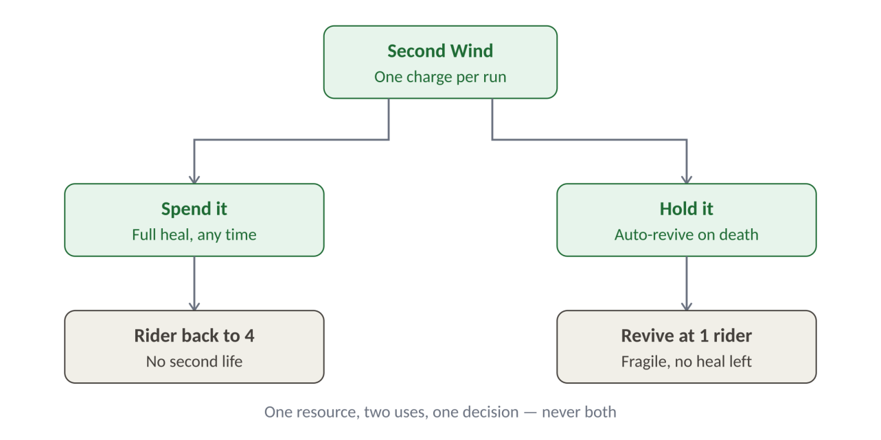
Second Wind. One charge, two ways to spend it, and the decision is the character.
Lynn is not the strongest survivor. She is the one who decides when to survive. A single shared charge is what makes the decision real — two independent systems would make it automatic.
Presentation rule: Last Breath must be sold as a moment. Freeze the frame, cut the music, shift the palette, resume. A revive that happens quietly reads as a bug.

10. Power-ups

Power-ups spawn in-lane, are collected in-run, and are consumed in-run. They never persist across runs and they are never for sale.
Power-up | Effect | Duration | Notes
Repair | Restores 1 Chassis plate, to class maximum | Instant | Caps at the class value — Mach receives one plate, not four
Med-kit | Restores 1 Rider point, to class maximum | Instant | Never grants a life above the class cap
Shield | Absorbs the next Chip or Heavy hit entirely, chain intact | Until consumed | Does not stop a Lethal hazard. Nothing does.
Double coins | Coin pickups count twice | 20 seconds | The only power-up that touches the economy
Magnet | Coins are drawn toward the rider | 15 seconds | Score-neutral; convenience only
Overdrive | Speed increased sharply; hazards arrive faster | 10 seconds | Raises chain opportunity and chain risk together
Phase | Chip hazards pass harmlessly through the rider | 5 seconds | Chain continues. No effect on Heavy or Lethal.

10.1 Rules that must hold
- Nothing stops a lethal hazard. Not Shield, not Phase, not Overdrive. The only exception in the entire game is Last Breath, and it revives — it does not prevent.
- Repair does not make everyone Brute. Brute repairs at will, repeatedly, by playing aggressively. Repair is an occasional pickup capped at the class maximum. His economy is renewable; theirs is topped up.
- Shield preserves the chain. A shielded hit is not damage. This makes Shield the most valuable power-up on the Open board and the least valuable on the class boards.
- Double coins is the only power-up with economic consequence and therefore the only one that must be included in the deterministic replay for verification.

11. Balance Model

11.1 Three resource economies
Class | Resource | Behaves like | Earned by | Lost by
Dasher | Momentum | A flow | Risk — grounded time and near-misses | Every air jump
Bulwark | Chassis | A renewable reserve | Aggression — smashing blockades | Every chip impact
Healer | Second Wind | A single charge | Nothing. It is granted at the start. | Using it, once

11.2 The hazard matrix
Every class has exactly one hazard tier it cannot answer.
Hazard | Mach (Dasher) | Brute (Bulwark) | Lynn (Healer)
Chip | Jumps it | Ignores it — 4 plates | Absorbs it
Blockade | Jumps it | Smashes it, gains a plate | Absorbs it
Ditch | Jumps it | Nothing. Takes the hit. | Absorbs it
Lethal | Steers, or Surge Jumps the line | Steers | Steers, or revives
Mach must never run dry on Momentum. Brute must never fall in a ditch. Lynn must never waste her charge. Those three sentences are the game.

11.3 Durability and speed
Class | vs Chip | vs Heavy | Base speed | Run shape
Dasher | 4 hits | 2 hits | Highest | High variance — highest ceiling, lowest floor
Bulwark | 6 hits | 2 hits | Medium | Untouchable, then instant
Healer | 6 hits | 4 hits (+1 revive) | Lowest | Lives longest, crawls
Bulwark and Healer are identical against chip damage and diverge entirely against heavy damage, where Bulwark's four plates count for nothing. Bulwark buys that back by deleting blockades outright and by moving faster. This is the axis on which the two durable classes are separated, and it is the first thing to verify in playtest.

11.4 On equalising speed
Speed is the only cost every class pays. Equalise it and Lynn becomes a strictly better Brute, and Mach a strictly worse everyone. If speed is ever equalised, the cost must move to a score multiplier or to hitbox size.
Recommendation: keep speed differentiated. A player understands "she is slow, so she covers less ground" without being told. A score multiplier is a number in a spreadsheet that players will call unfair even when it is mathematically identical. Speed is a balance lever that explains itself.
Versus is the exception, and the Sweeper handles it: there, speed is not a scoring cost but a survival one.

11.5 Adding classes later
- A new class must introduce a new resource economy. If the resource behaves like an existing one, it is a character, not a class.
- A new class must be free on release. The moment a class is sold, USDC buys ability.
- New characters are unlimited. They cost art and a name. Ship them freely.

12. Progression and Player Level

12.1 The principle
The Open board pools all three classes and ranks them on chain score. If level grants anything mechanical — a plate, a point of Rider, a wider near-miss window — the board ranks hours played rather than skill, and no new player can ever win it.
A level 40 player and a level 1 player, on the same seed, have identical stats, identical resources and identical odds. A player who installed the game this morning must be able to top the Open board tonight. Level buys breadth. It never buys power.

12.2 Three tracks
Track | Earned by | Resets | Grants
Account Level | Every completed run, any mode, win or lose | Never | Content and cosmetics
Class Mastery | Playing one specific class | Never | Class identity and earned characters
Season Rank | Open board placement and Versus rating | Every season | Competitive standing only
Account Level answers "my time mattered". Class Mastery answers "I main Lynn". Season Rank answers "I am good right now". Three different needs; none substitutes for another.

12.3 What Account Level unlocks
Unlock | Detail | Why it is safe
Time Attack tracks | Three authored tracks at level 1, rising to thirty by level 40. Each has its own leaderboard. | More game, not more power. A veteran has more boards to be excellent on.
Lane themes | Visual reskins of the running environment | Cosmetic
Bike frames | Silhouette variants of the shared frame | No stat change of any kind
Costume slots | Capacity to hold more owned costumes | Storage, not advantage
Level badge | Displayed beside the player name on every board | Prestige is the reward, and visibility is the payoff
Time Attack track gating is the mechanism that makes Account Level bite. It costs nothing beyond level design already planned, it cannot be bought, and it visibly separates a player with three hundred hours from a player with three.

12.4 What Class Mastery unlocks
- Class liveries and titles. Cosmetic, permanent, worn on the class boards.
- Earned characters. At mastery milestones, a new named rider within that class, granted free for playing.
Earned characters make the economy healthier. Free players gain a path to identity; buyers retain scarcity and tradability. The two populations stop resenting each other.

12.5 Earned characters versus bought characters
 | Earned | Bought
Obtained by | Class Mastery milestones | USDC
Ownership model | Off-chain entitlement | Soroban NFT
Tradable | No — never | Yes
Art | Distinct characters | Distinct characters
Affects gameplay | No | No
Earned characters are never tradable. If playing the game produced a tradable asset, value would flow out of gameplay into a market — coins in, assets out — which is precisely the two-way exchange that risks VASP classification. This rule is regulatory, not aesthetic, and it is not negotiable.

12.6 Rules that must hold
- XP is never purchasable. USDC cannot buy a level. If prestige is for sale, it is not prestige.
- XP is not a score. Grinding easy runs raises level and never rank. Level and leaderboard are separate systems that never touch.
- Level never touches Rider, Chassis, Momentum, Second Wind, speed, coin yield, or power-up spawn rates.
- Level is displayed everywhere. Open board, Versus lobby, profile. Visibility is the entire payoff.

12.7 The coin multiplier, and why it is rejected
The obvious way to make level pay out economically is a coin-yield multiplier at higher levels. It is rejected. Coins buy bike handling; handling affects play; a coin multiplier is therefore a slow-acting power advantage, and it penalises exactly the new players the Open board depends on. If it is ever adopted, it must be capped hard and disclosed publicly.

13. Economy

13.1 Bikes and costumes
- One silhouette, three liveries. All classes ride the same frame, recoloured to the class palette.
- Bikes upgrade with coins. Handling, acceleration, turn radius, top speed. Never Chassis, Rider, or any class resource.
- Costumes are purely cosmetic. Unlocked with coins or bought directly with USDC.

13.2 Currencies
Currency | Type | Earned by | Bought with | Cashable out
Coins | Soft | Playing (verified runs only) | USDC | No — never
USDC | Hard | Not earnable in-game | External wallet | n/a — is the rail
Coins are strictly one-way. They flow in through play or purchase and out only into bikes and costumes. Coins have no redemption path back into USDC or any other asset of value.

13.3 What USDC buys
Item | Ownership model | Tradable | Affects gameplay
Characters | Soroban NFT — held in player wallet | Yes | No
Costumes | USDC-gated unlock — off-chain entitlement | No | No
Bikes | Coin-purchased unlock — off-chain entitlement | No | Handling and speed only
Coins | Balance, not asset | No | No
Classes | Not for sale | — | Yes — which is why they are free
Power-ups | Not for sale | — | Yes — which is why they are found, not bought

14. Technical Architecture

14.1 The boundary
The single most important technical rule: the chain never sees gameplay.
Layer | Runs on | Responsible for
Client | Browser (Phaser 3) | Rendering, input capture, local physics prediction, telegraph display
Game server | Node / Colyseus | Lane seed authority, deterministic replay, result verification, matchmaking
Backend | Application DB | Coin balances, entitlements, leaderboards, sessions
Soroban | Stellar | Character NFT minting and transfer, USDC purchase settlement

14.2 Result verification
Because coins have purchasable value, a spoofed run is not cheating on a leaderboard — it is counterfeiting currency.
- 1. The server issues the lane seed. The client cannot choose its own hazards or power-up placements.
- 2. The client submits a timestamped input log for the run, not a score.
- 3. The server replays the input log against the seed using the same deterministic simulation.
- 4. If the replayed outcome matches the claim, coins mint and both leaderboards update. If not, the run is void.
Chassis, Rider, Momentum, Second Wind, chain state and every power-up are part of the replayed simulation. None is ever trusted from the client.

14.3 Versus networking
Because players cannot affect each other, Versus needs no authoritative real-time simulation, no client-side prediction, and no lag compensation. The server broadcasts each player's position for display, drives the Sweeper from a shared clock, and receives two elimination timestamps. It is a relay, not a game server.

14.4 Keeping the PvP door open
A server-authoritative deterministic simulation with timestamped input logs is precisely the foundation rollback netcode requires. Adding player collision later is an expansion, not a rewrite.

15. Risks

15.1 Design
- Instant death is the highest-risk mechanic in the game. It is the fastest route to a player quitting. If a tester says "that was unfair" even once, the telegraph is wrong.
- Bulwark may not function. If blockades are rare, Brute has no chassis economy and no chain. Verify in P1.
- Chain scoring may not be legible. Players understand distance instinctively. If playtesters cannot explain their own score, the HUD has failed, not the mechanic.

15.2 Economic
- Coin inflation: If coins mint faster than the shop absorbs them, upgrades lose meaning. Double coins must be included in the model.
- Pay-to-win drift: The class/character split will come under commercial pressure the first time a class would sell well. Defend it in code review, not just in this document.

15.3 Regulatory
Coins are purchasable with USDC. If coins were ever redeemable back into USDC or any transferable asset, the game would be operating a two-way exchange of value — which under Nigerian law risks classification as a Virtual Asset Service Provider.
- Mitigation: Coins are permanently one-way and non-transferable between players. Character NFTs are tradable but are bought, never earned, and never redeemed by us for currency.
- Action: Review with counsel before any USDC transaction goes live on mainnet.

15.4 Brand
- Name collision: "Hyperlane" is an established blockchain interoperability protocol. Resolve before registering any organisation, domain, or trademark.

15.5 Technical
- Determinism drift: Floating-point differences between client and server will silently void legitimate runs. Use fixed-point arithmetic from day one.
- Wallet friction: Players must be able to play Endless mode fully, with any class, before ever seeing a wallet prompt.

16. Open Decisions

# | Decision | Blocks | Owner | Needed by
D1 | Momentum fill rate, drain per air jump, near-miss margin | Dasher feel, and Open board balance
D2 | Blockade spawn frequency and Smash cooldown | Whether Bulwark functions at all
D3 | Chain multiplier curve — linear or accelerating | Whether the Open board rewards consistency or streaks
D4 | Exact speed multipliers per class | Class board balance
D5 | Sweeper pace, and whether it accelerates | Versus match length
D6 | Lethal hazard frequency, and whether it scales with distance | Fairness at high scores
D7 | Power-up spawn rates | Economy model and difficulty curve
D8 | Hazard generation: procedural, authored, or hybrid | Level design, seed architecture
D9 | Coin yield per minute and upgrade cost curve | Shop pricing
D10 | Character NFT supply per class — unlimited or capped | Soroban contract design
D11 | Whether Overdrive is capped on Mach | Whether the fastest class can survive the fastest power-up
D12 | Season length and leaderboard reset cadence | Backend schema
D13 | The project name | Everything downstream of registration
D14 | XP curve, and how many levels exist | Time Attack track gating schedule
D15 | Class Mastery milestone thresholds and how many earned characters per class | Art budget
D16 | Whether Season Rank resets fully or decays | Retention across seasons

17. Explicitly Out of Scope for v1

- Player-versus-player interaction of any kind
- More than two players in Versus
- A fourth class
- Selling classes, power-ups, or any ability for USDC
- Any mechanic that prevents a lethal hazard
- Distance contributing to the Open board
- Chain score contributing to the Versus rating
- Native mobile applications
- Coin-to-USDC redemption
- Player-to-player coin transfer

Retired terminology: "Block" and "Brut" both refer to the Bulwark class, whose default character is Brute. "HP" is now Rider. "DEF" is now Chassis. "Score is distance" is superseded by chain scoring. None of these terms should appear in any future document.

